Plate Scan

Vrusha Patel, Matt Downs, Fatema Cheema, Anam Kiani

University of Missouri – Kansas City

Table of Contents
Vision Statement 3
Requirements 4
Product Backlog 5
Sprint #1 6
Review 6
Retrospective 6
Sprint #2 7
Review 7
Retrospective 7
Sprint #3 8
Review 8
Retrospective 8
Sprint #4 9
Review 9
Retrospective 9
Sprint #5 10
Review 10
Retrospective 10
Sprint #6 11
Review 11
Retrospective 11

Vision Statement

Working with license plate recognition software and informational API’s, we empower the everyday driver with our license plate scanning technology to analyze the roads for criminals and violators in return for cash rewards.

Requirements
A discussion of what your application is required to have in functionality. It should identify user roles and goals/actions, and what the key features of the app should be.
Actor | Goal
Plate Recognition | Plate recognition will actively search license plate in recording mode or detect a license plate in phot mode
Convert License plate image to text | Image converter will convert image by finding numbers and letters in image and will return as string variable.
API Usage (Open ilpr) | Will send string to external API to detect any notices on license number
Design use interface for app | Design for the user interface to make it user friendly
Documentation (methods, class, etc) | Complete outlook for classes and methods used for programming
Graphics (images, vector, etc) | Creating graphics like images with photoshop to trademark application design
User Profile (saved to database) | Using database to create user profile under each license plate number
Persistent storage | Persistent storage will be used for showing previously scanned vehicles and make it easier for user to recall previous searches
Push notification for the reward system | Push notification for the reward system
Photo mode and driving mode | Differentiating between walking and driving modes to capture images and videos
Create database | Creating a database inside the app. Open ended for now
Unit Testing | Usability testing with different users to see the quality and ease of using the application

Product Backlog
This will be updated throughout the semester as new PBIs are added, larger items are broken into smaller ones, and completed items removed.

Story ID | Story | Story Points  (in est. hours) | Priority | Status
1 | Plate recognition – app need to be able to scan the plate | 2 | 1 | Completed
2 | Converts image to text- once the number plate is scanned in the app will need to analyze the text and read it in | 2 | 2 | Completed
3 | API usage – the text that has been read by the app will send a http request and get an http response on the information about the plate | 1 | 3 | In progress
4 | Driving/Photo mode – be able to switch between two different modes in the app. Driving mode will be a continuous video recording. Phot mode will require taking a picture at a time of the plates. | 4 | 4 | Idle

Sprint #1

Sprint Backlog
Story ID | Story / Task | Estimated  Hours | Actual  Hours
1 | Camera and Open ALPR | 2 | 1.5
2 | Documentation | 1 | 1

The system shall include an about menu which will explain the use of the app and how the app will work.

Review
https://github.com/Everest84/PlateScan - this is the link to the code.
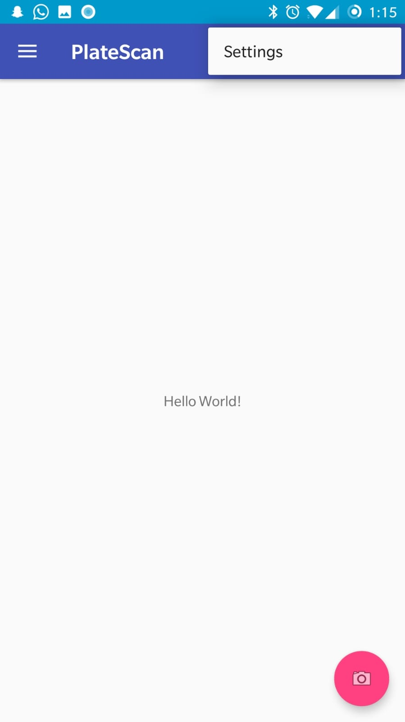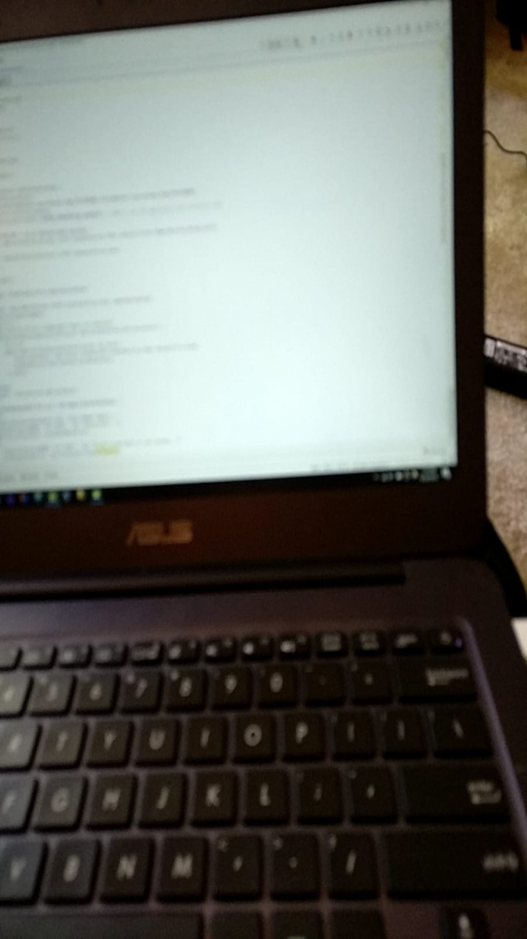
Got the camera working to scan the number plates. Image 1 is of what the plate scan looks like inside the app, image 2 is the camera in the app that was able to take a picture.

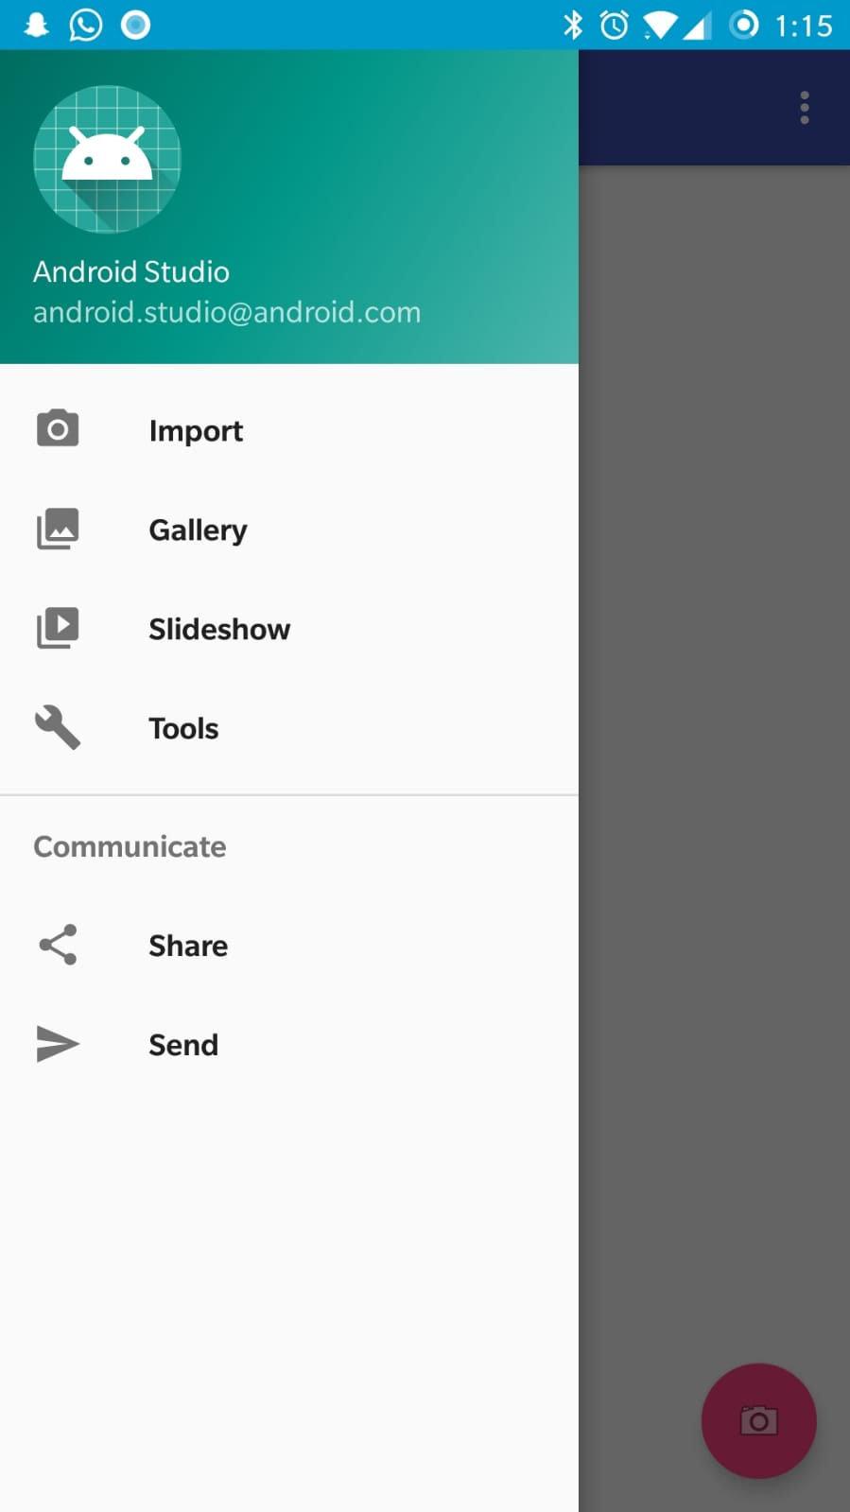
This image shows the menu inside the app that will have help, about, license plate history, and rewards tabs. The help button on the menu will give a brief walkthrough on how the app works and what it does. The about button on the menu will tell you about who made the app, the license plate history tab will allow you to view the license plates that have been scanned in by the user, and the rewards button will show the user the rewards they received if the license plate they scanned hit the radar.

Retrospective
Creating the camera to be able to take the pictures of the license plate wasn’t difficult to set up but understanding how to implement API was quite difficult. We have gotten a better grasp of it and will be able to import the library into the app for the next sprint, that will allow the user to take the phot and the library will accept the photo as a parameter and returns a result object that contains all the information of the car.

Sprint #2

Sprint Backlog
Story ID | Story / Task | Estimated  Hours | Actual  Hours
3 | Image to text | 2 | 3
2 | Documentation | 1 | 1

Review
https://github.com/Everest84/PlateScan - this is the link to the code.

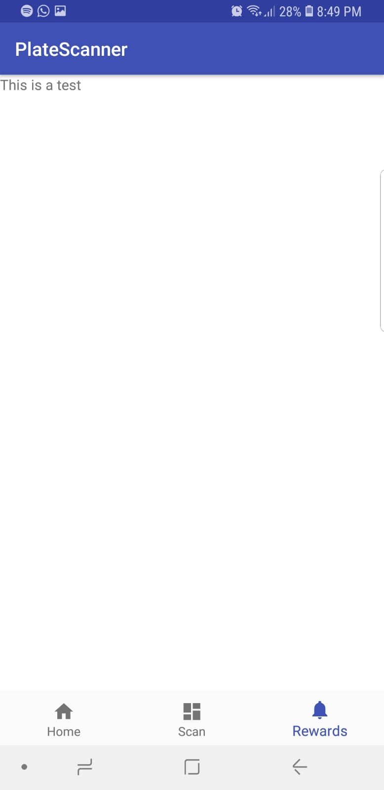
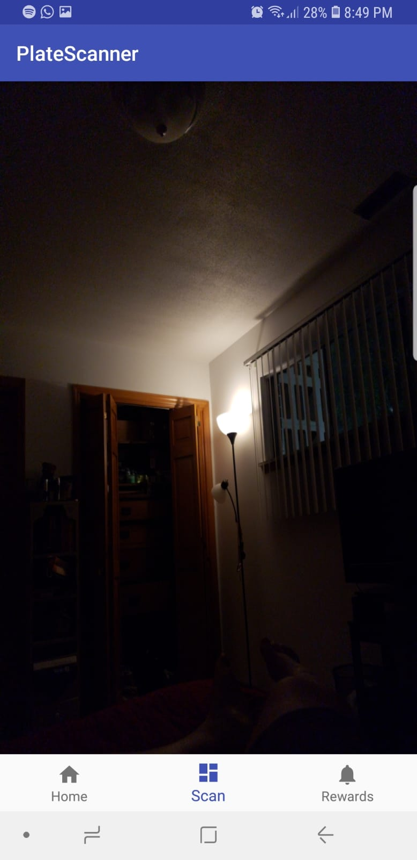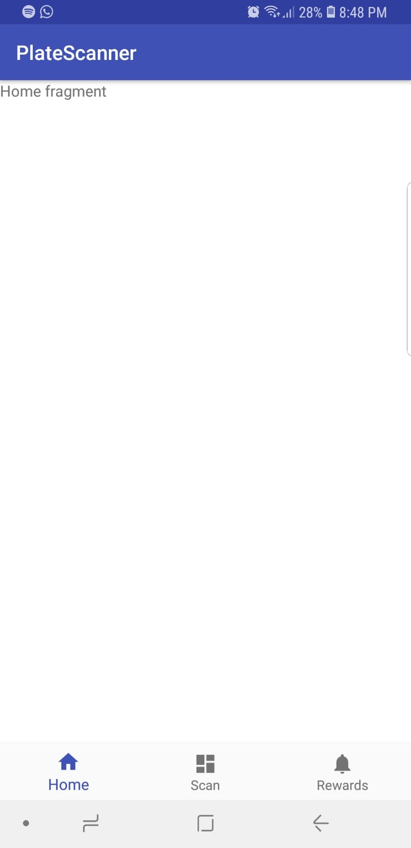

Creating the camera that takes pictures of the license plate was completed in the last sprint, In this one we are trying to get the license plate image to convert to text. Once the image of the number plate is scanned in the app it will need to analyze the text and read it in so that it can send an http request to and get an http response on information about the number plate that was scanned in.

Retrospective
We got ahead on sprint 1 and were able to create the camera that acknowledges the license plates, in this sprint we are having a little more difficulty trying to get the API to convert the images to send a http request and get an http response on the information about the plate. We underestimated the time it would take us to complete this task.

Sprint #3

Sprint Backlog
Story ID | Story / Task | Estimated  Hours | Actual  Hours
4 | API Usage | 2 | 4
2 | Documentation | 1 | 1

Review

Image of the logo:

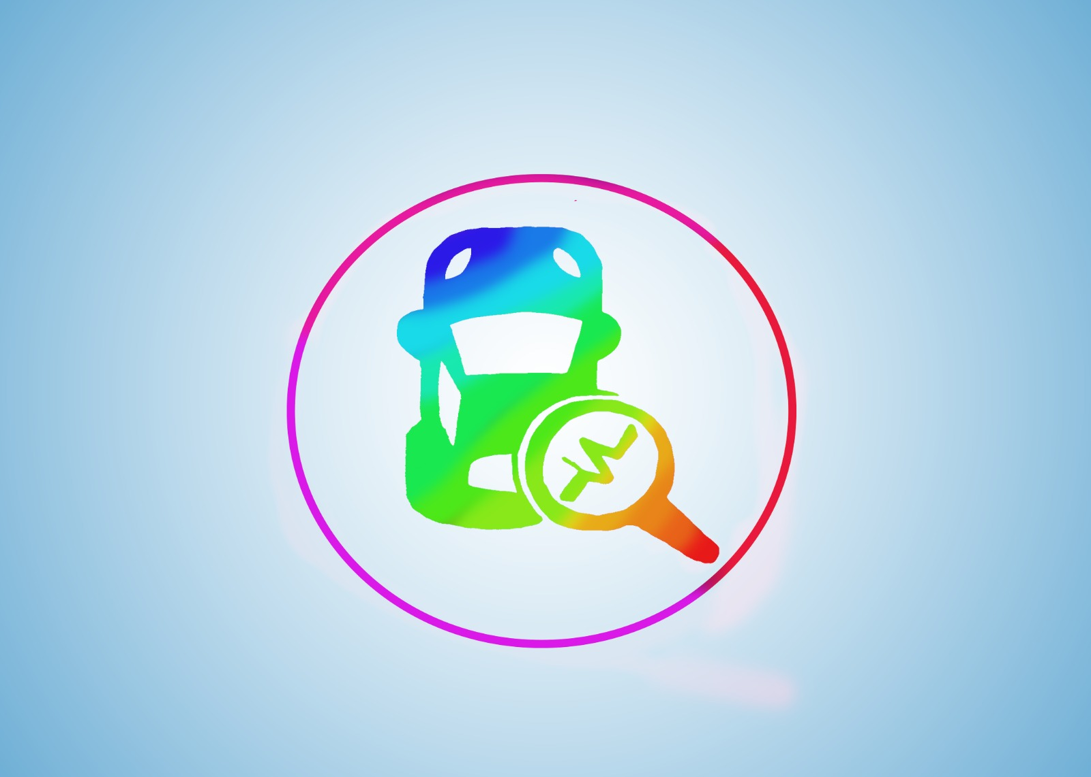

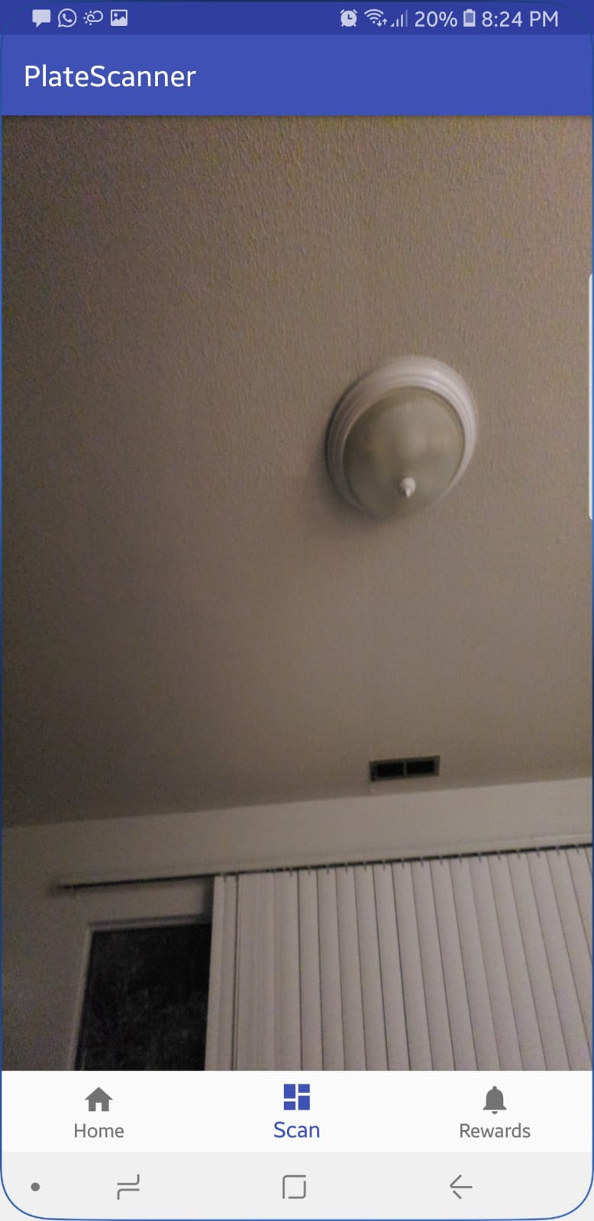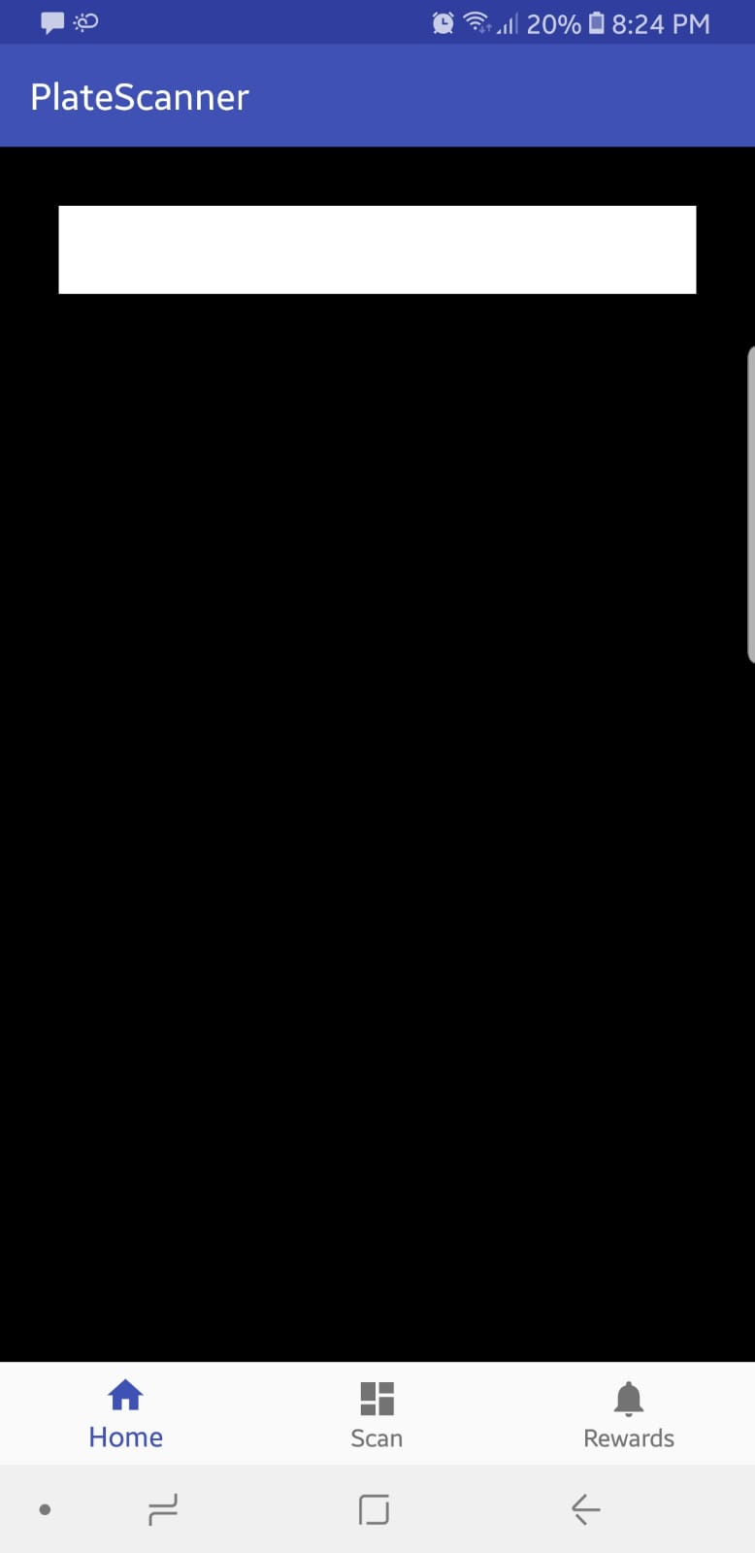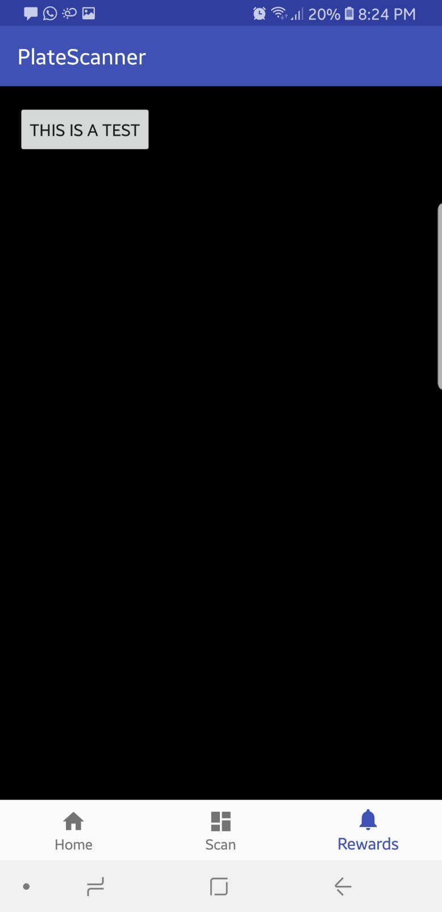

The logo for the app was completed in this sprint and the process of getting the app to connect with the API has started. The text being read by the app and then sending an http request to the API for information about the plate is functional, but getting the API to send an http response back to the app with the information of the plate is still a work in progress

Retrospective
Getting the app to read the text is a little more complex and getting the API to receive the request and send the response is also difficult. The app can send a http request to the API but there is some issue with getting the API to send an http response on the information about the plate. Still working on completing the processes of getting the API to connect completely with the app.

Sprint #4

Sprint Backlog
Story ID | Story / Task | Estimated  Hours | Actual  Hours
5 | Driving/photo mode | 2 | 0
6 | Persistent storage | 2 | 1
2 | Documentation | 1 | 1
4 | API Usage | 2 | 3
8 | User profile | 1 | 1

Review
Still having issues getting the API to send an http request back to the app. Work on creating a user profile to allow users to create a profile and save their license plate images that they have clicked has been started, but the process is not complete yet. We are having issues getting the app to create multiple profiles.

Retrospective
Creating the user profile went well, and was not that difficult, but getting the app to create multiple profiles is a little difficult. Though there is a minor code error that we are trying to figure out, we feel that switching around some of the tasks would be a good idea. Since the API is giving errors while trying to send an http request back to the app, creating the user profile and the user interface would be a better idea to complete. We will be working on the API connection as well, but it will take some time to resolve the errors.

Sprint #5

Sprint Backlog
Story ID | Story / Task | Estimated  Hours | Actual  Hours
7 | User Interface | 2 | 3
8 | User profile | 1 | 2
9 | Create database | 1 | 2
2 | Documentation | 1 | 1

Review
In this sprint we were able to further along our process in creating the application. For this sprint we focused on a lot of features including perfecting the user interface, and the user profiles. We did so by adding in a login screen for the users to be able to create accounts to save information and can start where they left off when they exit the app. We also added in the feature that will allow the users to save images of the number plates that they take. This would allow the user to save their data in case they have taken a picture of a number plate that may show up in the future.

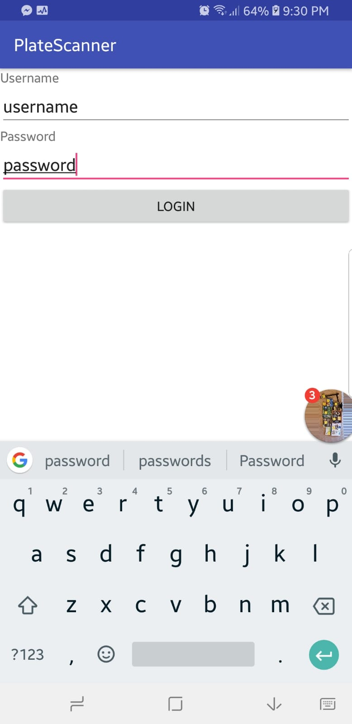

Retrospective
Over all with all the features added in this sprint, it was mostly a successful sprint. We initially had issues adding a login screen and adding a save button. But after some time, we were successfully able to. This would allow the user to save their data in case they have taken a picture of a number plate that may show up in the future. Overall the actual sprint hours took a little longer than anticipated with each story and task taking an hour more than anticipated.

Sprint #6

Sprint Backlog
Story ID | Story / Task | Estimated  Hours | Actual  Hours
10 | Graphics | 1 | 2
11 | Push notifications | 1 | 3
2 | Documentation | 1 | 1
12 | Unit testing | 1 | 2
5 | Driving/Photo Mode | 3 | Incomplete

Review
In this sprint we were able to establish a fire base connection for the push notification created, this would help the user to view the alerts and any information generated about the number plate. Also, this was the most time-consuming story ID in the sprint. We were also able to improve graphics and user interface this involved changing font, background, and overall app presentation. This last submission includes the source code for our project and a README file explaining all features of the PlateScan application.
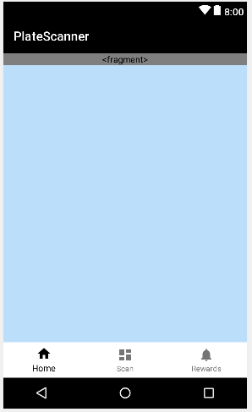

Retrospective
In our final sprint we were successful in accomplishing quite a few tasks on our list. This sprint took much longer and initially we faced difficulty creating fire base connection for the push notification created. Improving the GUI also took some time as it required a few code fixes. The one deficiency we have now is we were not successful in completing the ‘Driving/ Photo Mode’ story ID. Overall the project was successful and in a running state. We have learnt the basic principles and concepts of Agile development, working as a Scrum team. Also, each sprint had its own challenges and success stories throughout the semester.

